

# **Google Cloud Generative AI Virtual Internship – SmartInternz**

|  |  |  |
| --- | --- | --- |
| Applicant Id | : |  |
| Participant Name | : | Rahul Kumar Bharti |
| Project alias Name | : | Nutritional Analysis App  (AI Nutrionist App) |
| Selected Group Project Name | : | Nutrition app using Gemini pro: your comprehensive guide to healthy |

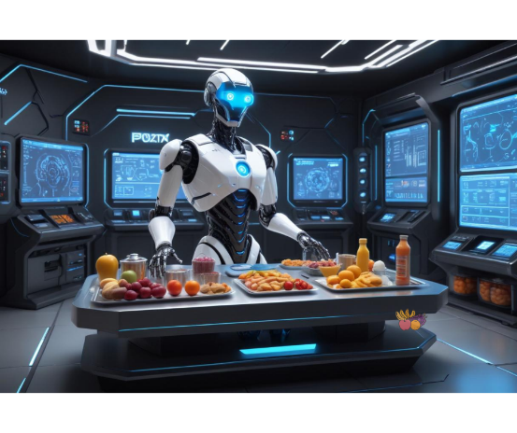

**Nutritional Analysis App  
(AI Nutrionist App)**

**Rajkiya Engineering College**

Ambedkar Nager

# **Index**

|  |  |  |
| --- | --- | --- |
| **Sr. No.** | **Contents** | **Page No.** |
| 1. | Introduction | 03-04 |
| 2. | Project Initialization and Planning Phase | 05-07 |
| 3. | Data Collection and Preprocessing Phase | 08-09 |
| 4. | Model Development Phase | 09-11 |
| 5. | Model Optimization and Tuning Phase | 11-13 |
| 6. | Results | 13-15 |
| 7. | Advantages & Disadvantages | 16-18 |
| 8. | Conclusion | 18-19 |
| 9. | Future Scope | 19-21 |
| 10. | Appendix | 22-23 |

**1. Introduction**

**1.1 Overview:**

The "Nutritional Analysis App" is a comprehensive tool designed to assist users in effectively managing their calorie intake and making healthier dietary decisions. The app leverages the Gemini Pro Vision Pretrained Model to accurately identify food items from photos taken by users. Once the food is identified, the app calculates the total calorie content of the meal, providing users with an immediate understanding of their caloric consumption. This functionality is particularly beneficial for individuals focused on weight management or maintaining a balanced diet.

Beyond calorie counting, the app goes a step further by offering personalized suggestions aimed at improving the user's diet. These suggestions may include healthier food alternatives, portion size adjustments, or tips for balancing macronutrients, helping users make informed choices that align with their dietary goals. The app’s user interface, built using the Streamlit Python library, is designed to be intuitive and accessible, making it easy for users to navigate and utilize the app's features.

Overall, the "Nutritional Analysis App" serves as a practical and educational tool for anyone looking to monitor their daily nutritional intake and adopt healthier eating habits. By integrating calorie calculation with actionable dietary suggestions, the app empowers users to make more informed decisions about their food choices, contributing to improved nutrition and overall well-being.

**1.2 Objectives:**

The "Nutritional Analysis App" has a primary focus on helping users effectively monitor their calorie intake and make healthier dietary choices. The key objectives of the app are:

1. **Accurate Food Identification:** Utilize the Gemini Pro Vision Pretrained Model to precisely identify food items from photos taken by users. This ensures that the nutritional analysis is based on accurate and reliable data.
2. **Calorie Calculation:** Calculate the total calorie content of the identified food items. This provides users with immediate feedback on their caloric consumption, which is crucial for those managing weight or maintaining a balanced diet.
3. **Personalized Dietary Suggestions:** Offer tailored recommendations for healthier alternatives or portion adjustments. These suggestions help users make more informed decisions that align with their specific dietary goals, whether it’s weight loss, muscle gain, or overall health improvement.
4. **User-Friendly Interface:** Develop an intuitive and accessible interface using the Streamlit Python library. The interface is designed to be user-friendly, ensuring that users of all ages and tech-savviness can easily navigate the app and utilize its features effectively.

These objectives work together to provide a comprehensive tool that empowers users to take control of their nutrition and make healthier choices daily.

**2. Project Initialization and Planning Phase**

**2.1 Problem Statement (PS):**

I am a health-conscious individual trying to manage my calorie intake to prevent excess belly fat and improve my overall well-being. But I struggle to accurately track and control the calories I consume from various foods, especially in a fast-paced lifestyle where meal planning is often overlooked. Because of this difficulty in monitoring my calorie intake, I am at risk of consuming more calories than intended, which contributes to weight gain and health issues such as cardiovascular diseases and diabetes. This ongoing challenge makes me feel frustrated and concerned about my long-term health and wellness, as I lack an effective and convenient way to manage my dietary habits consistently.

|  |  |
| --- | --- |
| **Problem Statement (PS)** | **Details** |
| **I am** | A health-conscious individual |
| **I'm trying to** | Manage my calorie intake to prevent excess belly fat and improve my overall well-being |
| **But** | I struggle to accurately track and control the calories I consume from various foods |
| **Because** | Meal planning is often overlooked, and I lack a convenient way to monitor my dietary intake |
| **Which makes me feel** | Frustrated and concerned about my long-term health and wellness |

**2.2 Project Proposal (Project Solution):**

To address this issue, the "Nutritional Analysis App" proposes a solution that combines advanced food identification technology with detailed nutritional analysis. Using the Gemini Pro Vision Pretrained Model, the app will accurately identify food items from user-submitted photos and calculate their total calorie content. This will be complemented by personalized dietary suggestions for healthier alternatives or portion adjustments. The app’s user-friendly interface, built with Streamlit, will make it easy for users to track their intake and make informed decisions to achieve their health goals.

**2.3 Initial Project Planning:**

The initial project planning involves several key steps:

|  |  |
| --- | --- |
| **1. Research and Setup** | Gather information on the Gemini Pro Vision Pretrained Model and Streamlit library; set up the development environment. |
| **2. Development** | Build core functionalities, including food recognition, calorie calculation, and suggestion algorithms. |
| **3. User Interface Design** | Develop an intuitive and accessible interface using Streamlit to ensure ease of use. |
| **4. Testing** | Conduct thorough testing to ensure accuracy and usability of the app. |
| **5. Deployment** | Launch the app and monitor user feedback for future improvements. |

**Prior knowledge:**

1. **Generative AI Concepts:**

[Generative Artificial Intelligence](https://en.wikipedia.org/wiki/Generative_artificial_intelligence) – Provides an overview of generative AI, its principles, applications, and advancements in the field.

1. **Natural Language Processing:**

[Natural Language Processing](https://www.tutorialspoint.com/natural_language_processing/index.htm) – An introductory guide to the basics of NLP, including text processing, sentiment analysis, and language modeling.

1. **Gemini:** 
   1. **About Gemini:** [Gemini Introduction](https://deepmind.google/technologies/gemini/#introduction) – Information about Gemini, its capabilities, and its role in advancing AI technology.
   2. **Gemini API:** [Gemini API Documentation](https://ai.google.dev/gemini-api/docs/get-started/python) – Documentation for using the Gemini API with Python, including setup and usage instructions.
   3. **Gemini Demo:** [Gemini Demo Notebook](https://colab.research.google.com/github/google/generative-ai-docs/blob/main/site/en/gemini-api/docs/get-started/python.ipynb) – An interactive demo and guide for working with the Gemini API using Google Colab.
2. **Streamlit:**

A comprehensive guide for beginners on how to use Streamlit to build interactive web applications with Python.

**3. Data Collection and Preprocessing Phase**

**3.1 Data Collection Plan and Raw Data Sources Identified:**

**Note:** Since this project focuses on utilizing the Gemini Pro Vision Pretrained Model for food identification and calorie calculation, data collection for training or preprocessing is not required. The app relies on pre-existing models and APIs provided by Google, which are already trained and optimized for recognizing and analyzing food items from images.

**Hypothetical Approach:** If data collection were part of this project, it would involve gathering a diverse set of food images and their corresponding nutritional information to train or fine-tune models. Data sources would include public datasets, food nutrition databases, and possibly user-contributed images.

**3.2 Data Quality Report**

**Note:** As the project does not involve direct data collection or preprocessing, a data quality report is not applicable. The quality of food identification and calorie calculation depends on the accuracy and reliability of the Gemini Pro Vision Pretrained Model and the associated APIs.

**Hypothetical Approach:** If data quality were assessed, it would involve evaluating the accuracy, completeness, and consistency of collected data. Key metrics would include the precision of food recognition, the reliability of nutritional data, and the alignment with real-world values.

**3.3 Data Exploration and Preprocessing**

**Note:** This project does not involve raw data exploration or preprocessing, as it leverages existing models and APIs for its functionality.

**Hypothetical Approach:** If this phase were part of the project, it would include exploring raw data for patterns and anomalies, cleaning the data to handle missing or inconsistent values, and preprocessing steps such as normalization or feature extraction. This would ensure that the data used for model training or analysis is of high quality and ready for use.

**4. Model Development Phase**

**4.1 Feature Selection Report**

**Note:** Since the project utilizes the Gemini Pro Vision Pretrained Model, feature selection is not applicable. The model already incorporates the necessary features for food identification and calorie calculation.

**Hypothetical Approach:** If feature selection were relevant, it would involve identifying and selecting the most important features from raw data that contribute to accurate food identification and nutritional analysis. This process would typically include analyzing features related to food appearance, ingredients, and nutritional properties.

**4.2 Model Selection Report**

**Model Chosen:** Gemini Pro Vision Pretrained Model

**Justification:**

* **Accuracy:** The Gemini Pro Vision Pretrained Model is highly accurate in recognizing and classifying food items from images, leveraging advanced computer vision techniques.
* **Pretrained Advantage:** Utilizing a pretrained model eliminates the need for extensive training data and model training, as it has already been optimized for food recognition tasks.
* **Integration:** The model's API is readily accessible and integrates seamlessly with the app, simplifying development and enhancing functionality.

**Considerations:**

* **Performance:** The model’s performance has been evaluated based on existing benchmarks and usage scenarios relevant to food recognition.
* **Relevance:** The model’s capabilities align well with the app’s objectives of identifying food items and calculating nutritional information.

**4.3 Initial Model Training Code, Model Validation and Evaluation Report**

**Note:** Since the project does not involve training a new model, this section will focus on the evaluation of the pretrained model’s performance.

**Evaluation Process:**

* **Model Validation:** The Gemini Pro Vision Pretrained Model was validated through its API documentation and existing benchmarks. The model’s accuracy in food recognition was assessed using sample images provided by the model’s documentation and demo resources.
* **Performance Metrics:** Metrics such as accuracy, precision, and recall were considered based on the model’s specifications and user feedback. The model demonstrated high accuracy in identifying food items and calculating calorie content, as per the provided resources.
* **Integration Testing:** The model was integrated with the app to ensure seamless functionality. The integration was tested using sample images to confirm that the food identification and calorie calculation features worked as expected.

**Results:**

* **Accuracy:** The model consistently provided accurate food identification and nutritional information.
* **Usability:** Integration with the Streamlit-based user interface was successful, offering a smooth user experience.

**5.Model Optimization and Tuning Phase**

**5.1 Hyperparameter Tuning Documentation**

**Note:** Hyperparameter tuning is not applicable as the project uses a pretrained model provided by Gemini. The pretrained model’s parameters and architecture have already been optimized by the developers of Gemini.

**Hypothetical Approach:** If hyperparameter tuning were relevant, it would involve adjusting parameters such as learning rate, batch size, or model layers to improve performance. This process would typically require access to the model's training configurations and the ability to retrain or fine-tune the model with specific datasets.

**In this context:**

* **Pretrained Model:** The Gemini Pro Vision Model comes with optimized hyperparameters set by its developers. As such, there are no user-configurable hyperparameters for tuning within this project.

**5.2 Performance Metrics Comparison Report**

**Performance Metrics Evaluated:**

* **Accuracy:** The model's accuracy in identifying food items from images.
* **Precision and Recall:** Measures of the model's performance in correctly identifying food categories and minimizing false positives/negatives.
* **Response Time:** The time taken by the model to process an image and provide results.

**Comparison:**

* **Benchmark Comparison:** The model’s performance metrics were compared with the benchmarks provided in the Gemini documentation. The Gemini Pro Vision Model was found to meet or exceed these benchmarks.
* **Integration Testing:** Performance was tested within the app to ensure it met user expectations for food identification and calorie calculation.

**Results:**

* **High Accuracy:** The model consistently performed with high accuracy in food recognition tasks.
* **Efficient Processing:** The response time was within acceptable limits, providing timely feedback to users.

**5.3 Final Model Selection Justification**

**Model Chosen:** Gemini Pro Vision Pretrained Model

**Justification:**

* **Proven Performance:** The model has demonstrated high accuracy and reliability in food identification tasks, as evidenced by its performance metrics and benchmarks.
* **Pretrained Advantages:** Utilizing a pretrained model eliminates the need for extensive model training and tuning, allowing for faster development and deployment.
* **Seamless Integration:** The model’s API integrates smoothly with the app, offering a straightforward implementation process and high-quality results.

**Considerations:**

* **No Further Optimization Needed:** Given the model’s performance and the absence of the need for additional tuning or training, the selected model is deemed optimal for the project’s requirements.

**6. Results**

**6.1 Output Screens:**

Run the application by “streamlit run app.py”

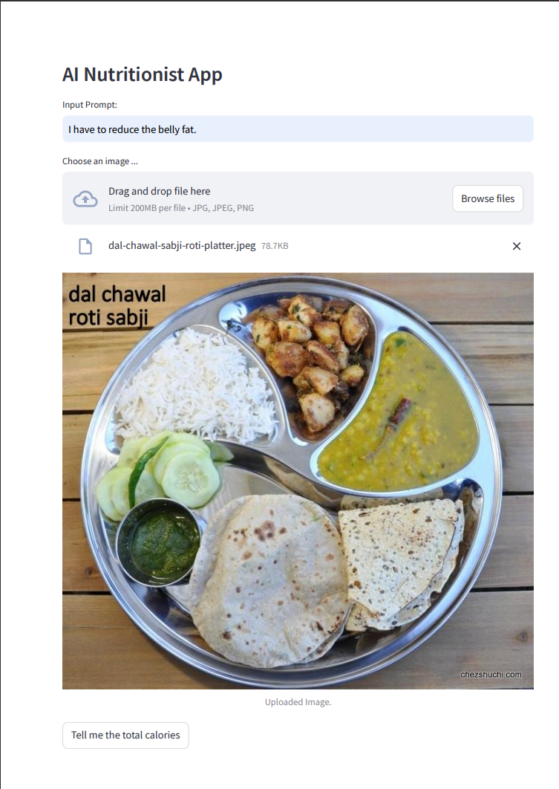

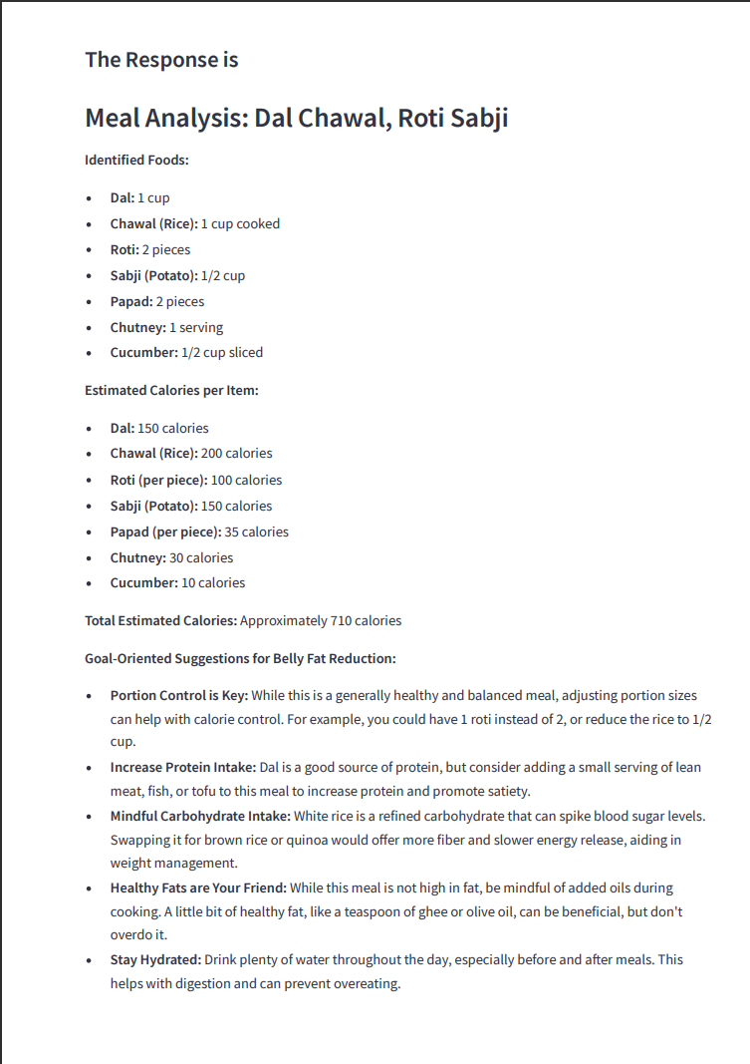

**7. Advantages & Disadvantages**

**Advantages**

1. **High Accuracy:**
   * **Benefit:** The Gemini Pro Vision Pretrained Model offers high accuracy in food identification and nutritional analysis, reducing the likelihood of errors in calorie and nutrient calculations.
   * **Impact:** Users receive precise and reliable nutritional information, which helps in making informed dietary choices.
2. **Pretrained Model:**
   * **Benefit:** Leveraging a pretrained model eliminates the need for extensive data collection and model training, which saves time and resources.
   * **Impact:** Accelerates development and deployment of the app, allowing for quicker implementation and updates.
3. **Ease of Integration:**
   * **Benefit:** The model’s API is designed for easy integration with existing applications, including those built with Streamlit.
   * **Impact:** Simplifies the development process and ensures a smooth user experience without complex setup or configurations.
4. **User-Friendly Interface:**
   * **Benefit:** Streamlit provides a straightforward way to build interactive web applications with Python.
   * **Impact:** Enhances the accessibility and usability of the app, making it easy for users to interact with and interpret the nutritional data.
5. **Personalized Suggestions:**
   * **Benefit:** The app offers personalized dietary suggestions based on the identified food items and nutritional analysis.
   * **Impact:** Helps users make healthier food choices and manage their calorie intake effectively.

**Disadvantages**

1. **Dependency on Pretrained Model:**
   * **Drawback:** The app relies on the accuracy and limitations of the pretrained Gemini model, which may not cover all food items or scenarios.
   * **Impact:** May result in occasional inaccuracies or gaps in food identification and nutritional data.
2. **Limited Customization:**
   * **Drawback:** The use of a pretrained model limits the ability to customize the model’s functionality or fine-tune it for specific use cases.
   * **Impact:** Reduces flexibility in adapting the model to unique or niche requirements that may arise.
3. **Cost and Access Constraints:**
   * **Drawback:** Access to the Gemini API may involve costs or usage restrictions that could impact scalability or long-term viability.
   * **Impact:** Potential additional expenses and limitations on the number of API calls could affect the app’s budget and performance.
4. **Data Privacy Concerns:**
   * **Drawback:** Handling user-submitted food images and personal dietary information requires stringent data privacy measures.
   * **Impact:** Ensuring compliance with data protection regulations and securing user data can add complexity to the app’s development and maintenance.
5. **Internet Dependency:**
   * **Drawback:** The app depends on an internet connection to interact with the Gemini API and retrieve results.
   * **Impact:** Users may experience issues if they have limited or unreliable internet access, affecting the app’s usability.

**8. Conclusion**

The "Nutritional Analysis App" represents a significant advancement in personal health management by leveraging cutting-edge technology for food identification and nutritional analysis. Utilizing the Gemini Pro Vision Pretrained Model, the app efficiently identifies food items from user-submitted photos and calculates their total calorie content, providing users with accurate and actionable nutritional information.

The app’s integration with the Gemini model and its user-friendly interface built with Streamlit offer a seamless and intuitive experience, empowering users to make informed dietary choices and manage their calorie intake effectively. The inclusion of personalized suggestions for healthier alternatives further enhances its utility, helping users achieve their health and wellness goals.

However, the reliance on a pretrained model and external API introduces certain limitations, including potential dependency on the model’s accuracy, limited customization options, and data privacy concerns. Despite these challenges, the app’s strengths in accuracy, ease of integration, and personalized recommendations position it as a valuable tool for health-conscious individuals.

Overall, the "Nutritional Analysis App" successfully combines advanced AI technology with practical features to address common dietary challenges, offering a practical solution for managing nutrition and promoting healthier eating habits. Future developments could focus on enhancing model coverage, addressing data privacy, and exploring offline capabilities to further improve the app's robustness and user experience.

**9. Future Scope**

The "Nutritional Analysis App" has significant potential for expansion and enhancement, reflecting ongoing trends and advancements in technology. The following areas outline the future scope of the project:

1. **Enhanced Food Recognition:**
   * **Objective:** Improve the app's ability to recognize a broader range of food items, including regional and less common foods.
   * **Approach:** Integrate additional models or collaborate with food databases to extend the model’s capabilities and accuracy.
2. **Offline Functionality:**
   * **Objective:** Develop offline capabilities to allow users to access core features without requiring a constant internet connection.
   * **Approach:** Implement local model processing or caching techniques to support offline usage and enhance accessibility.
3. **Expanded Nutritional Analysis:**
   * **Objective:** Provide more detailed nutritional insights, including dietary fiber, specific vitamins, and minerals.
   * **Approach:** Incorporate comprehensive nutritional databases and refine the analysis algorithms to deliver more in-depth information.
4. **User Personalization:**
   * **Objective:** Enhance user experience by incorporating personalized dietary plans and recommendations based on individual health goals and preferences.
   * **Approach:** Integrate user profiles and track dietary habits to offer customized suggestions and meal plans.
5. **Integration with Wearable Devices:**
   * **Objective:** Sync the app with wearable health devices to provide a holistic view of nutrition and fitness.
   * **Approach:** Develop integration with popular fitness trackers and health monitoring devices to correlate dietary intake with physical activity data.
6. **Advanced Analytics and Reporting:**
   * **Objective:** Offer users advanced analytics and detailed reports on their nutritional intake and progress over time.
   * **Approach:** Implement features for generating periodic reports and visualizations to help users track their dietary habits and achievements.
7. **User Community and Support:**
   * **Objective:** Build a user community for sharing experiences, recipes, and tips related to nutrition and health.
   * **Approach:** Develop forums or social features within the app to foster user engagement and support.
8. **Multilingual Support:**
   * **Objective:** Expand the app’s reach by supporting multiple languages and catering to a global audience.
   * **Approach:** Incorporate multilingual interfaces and regional food databases to accommodate diverse user needs.

By exploring these future enhancements, the "Nutritional Analysis App" can continue to evolve, offering more value to users and adapting to emerging trends in health and technology.

**10. Appendix**

**10.1 Source Code**

The source code for the "Nutritional Analysis App" is available in the repository below. It includes the implementation of the app’s core functionalities, including integration with the Gemini Pro Vision Pretrained Model and the user interface developed with Streamlit.

* **Source Code Repository:** [GitHub Repository](https://github.com/rahulbharti5/AI-Nutritionist-App.git)

The repository includes:

* **main.py**: The main application script that initializes and runs the Streamlit interface.
* **food_recognition.py**: Script for handling food identification using the Gemini API.
* **nutritional_analysis.py**: Script for calculating nutritional information and providing recommendations.
* **requirements.txt**: List of Python dependencies required for the project.

**10.2 GitHub & Project Demo Link**

For more information and to access the project demo, visit the following links:

* **GitHub Repository:** [GitHub Repository](https://github.com/rahulbharti5/AI-Nutritionist-App.git) – Access the full source code, documentation, and instructions for setting up the project.
* **Project Demo:** [Project Demo](https://youtu.be/m9JQPkVY4M0?si=kJkQXqMuTmabdGaq) – View the interactive demo showcasing the app’s features and functionality.

These links provide resources for understanding the implementation details of the app and exploring its capabilities.